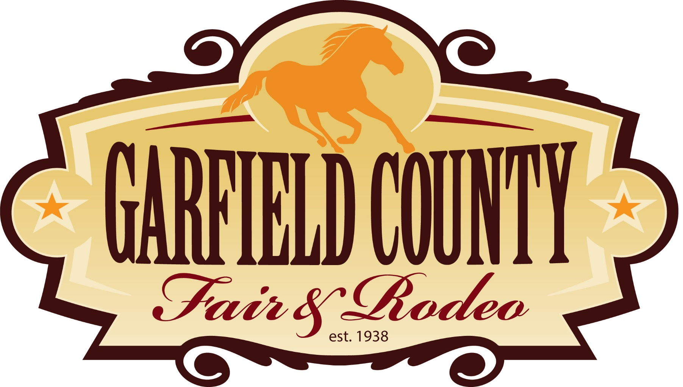

Summer of Thunder Car Show
Car Show
Garfield County Fair
Saturday August 1, 2026
12:00 p.m. till 4 p.m.

Name: ____________________________________

Address: ____________________________________

City: ____________________________________State: ________________ Zip: ______________________

Phone _____________________________________Club affiliation: ____________________________________

E-mail: ____________________________________
Fax: ____________________________________

Division: _Classic _Street Rod _Custom _Original _Rat rod _Other ____________________________________

Vehicle Year _______ Make ________________Model ______________________________
Body Style ____________________________________

First 100 entries will receive a free T-shirt, there will be trophies for class winners. The Car Show is located in Rifle, Colorado at the Garfield County fairgrounds 1000 Railroad Ave.

$25 before July 20 ~ $30 day of car show ~ Extra event T-shirt $15 S - XL, $20 XXL

Release: This release form must be signed and returned with payment for acceptance.

Liability: Entrants and participants, by signing this form, hold harmless the Garfield County Fair and Car Show and/or any of their agents, directors or representatives or anyone else connected with this event, from known or unknown acts or damages, injuries, losses and/or claims whatsoever they may suffer by anyone or anything to their persons and property. The event will be held rain or shine. I hereby grant full permission to the Garfield County Fair Car Show to photograph, motion picture, videotape, recording or any other record of this event for any legitimate purpose.

Please make checks payable to: Garfield County Treasurer

Print, sign and return this form and payment to:
Levy Burris
669 County Road 326, Silt, CO 81652
970-589-7903 Lredman95@icloud.com

Signature ____________________________________

Legal guardian if under 18______________________________________________________Date ____________

